Business Analysis Case Study: Online Music Retailer (Descriptive Report + SQL)

Table of Contents

Introduction 3

Descriptive Analytics on Payments 3

Data Visualization with Charts 4

Customer Segmentation Based on Payments 6

Top 6 Selling Genres 6

Sales by Country 7

Customer Purchase History 8

Album Count 8

Customer Information 9

Artist Influence 10

Most common Media Type 10

Conclusion 11

# Introduction

The online music retail business is primarily built around vast customer traffic and available music streams. A deeper analysis of customer behaviour, sales trends, and genre popularity can help businesses better understand how to run efficiently and make informed decisions. This analysis will focus on a music store’s database, and with the help of SQL queries, we will extract relevant information to perform a comprehensive analysis. Descriptive statistics, visualization, and customized querying will help us focus on the following aspects of the business:

1. Customer spending patterns: Analyzing the customer’s payment data indicates how they spend money in the music store, which helps the store identify target customers based on their spending.
2. Sales of different countries: Analysis of sales by country and by genre to know the preferred genre and high-performing countries for expansion.
3. Customers from particular territories: Identifying customers from, for example, Canada, can help identify with the targeted customers and develop products specific to them.
4. Trends regarding artists and media: Identifying favorite artists and media will help the store acquire the necessary copyright and artist to increase their targeted audience.

This information will help the management team understand the insights to take to operate and improve the store’s efficiency.

# Descriptive Analytics on Payments

|  |  |  |  |
| --- | --- | --- | --- |
| **Statiscal Analysis** | | | |
| ***customerId*** | | ***Payments*** | |
|  |  |  |  |
| Mean | 29.92961165 | Mean | 5.651941748 |
| Standard Error | 0.838051365 | Standard Error | 0.233785121 |
| Median | 30 | Median | 3.96 |
| Mode | 2 | Mode | 1.98 |
| Standard Deviation | 17.01058485 | Standard Deviation | 4.745319694 |
| Sample Variance | 289.3599969 | Sample Variance | 22.51805899 |
| Kurtosis | -1.200196445 | Kurtosis | 1.059628637 |
| Skewness | 0.000359806 | Skewness | 1.213908311 |
| Range | 58 | Range | 24.87 |
| Minimum | 1 | Minimum | 0.99 |
| Maximum | 59 | Maximum | 25.86 |
| Sum | 12331 | Sum | 2328.6 |
| Count | 412 | Count | 412 |

The points of measure of central tendency are:

mean – the average value of the variable; for this dataset, the mean CustomerID is 29.93 and the mean total is 5.65.

median – the middle value upon rearranging the data from the least value to the greatest. It is 30 for the CustomerID and 3.96 for the total.

mode – the most frequent value. It is 2 for the CustomerID and 1.98 for the total.

The dispersion involves the following measures:

standard deviation – it demonstrates how the data scatters around the mean value or stands closer to it. A big standard deviation value indicates that data is scattered farther. The CustomerID realization has a standard deviation of 17.01, while the total is 4.75.

The shape has the following points as to statistics:

skewness – it is the distribution’s symmetry; when it is positive, the distribution is pulled to the right; when it is negative, the distribution is pulled to the left. The CustomerID realization has two, which is close to zero and indicates normal shape. The total realization has 1.21.

The kurtosis demonstrates the peak of the distribution. When it is 3, it is a normal distribution, when greater than 3, it is peaked, and when less than 3, it is flat. The CustomerID realization has a value of -1.20, and the total is 1.06.

# Data Visualization with Charts

The visualization was done for the data with the help of the Excel export and writing querry in the SQL to extract particular data for the visualization.

Chart1: This visualization would show the total sales for each country. You can use a bar chart where each bar represents a country, and the height of the bar represents the total sales in that country.

Chart2: Plot total sales over time to visualize sales trends. You can aggregate sales data by month or quarter and plot it on a line chart, with time on the x-axis and total sales on the y-axis.

a pie chart illustrating the distribution of track genres. Each slice of the pie represents a genre, with the size of the slice indicating the proportion of tracks in that genre.

# Customer Segmentation Based on Payments

# Top 6 Selling Genres

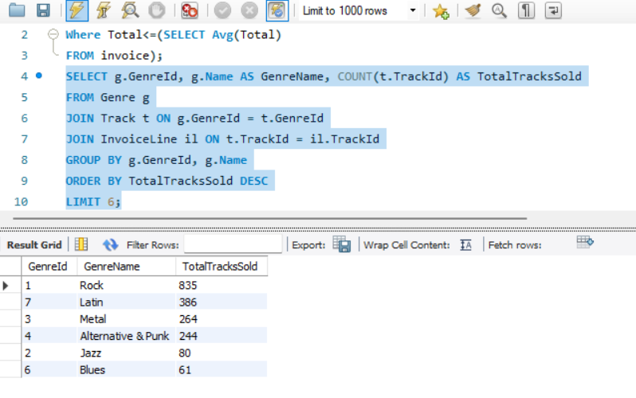

The top 6 Genere are Rock, Latin, Metal, Alternative, Jezz and Blues.

# Sales by Country

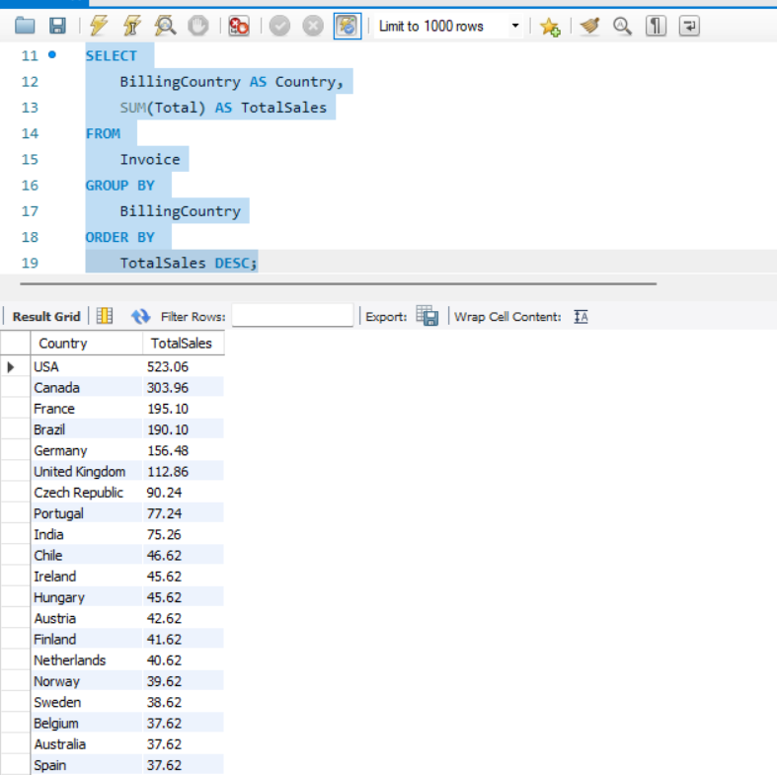

# Customer Purchase History

# Album Count

# Customer Information

# Artist Influence

# Most common Media Type

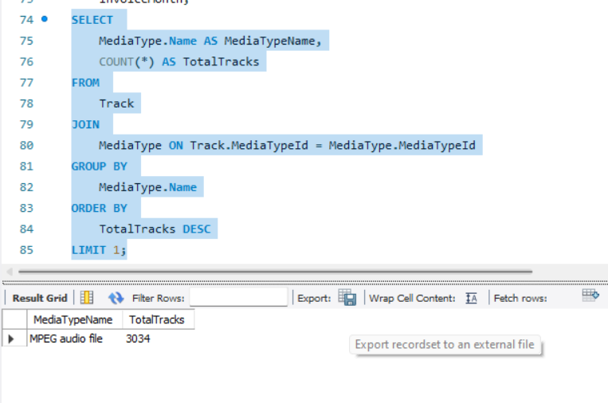

# Conclusion

In conclusion, the above comprehensive analysis of the music store’s database has revealed a wide range of data points, truths, and trends. Through descriptive statistics and database and business intelligence, the combination of data parameters, data visualizations, and SQL targeted queries has given me a better understanding of consumer purchasing behavior, sales trends, the effect of artists on sales trends, and media trends . I hope that the information provided above may assist the management in: this may help optimize their marketing strategies by offering distinct marketing messages about Canadian customers. This may also help streamline their content acquisition by shifting content weighing to music from well-known artists and from the trending media.